This is followed the [quickguide](http://pymeasure.readthedocs.io/en/latest/quick_start.html)

# Step 1: download and install Anaconda

# Step 2: Install Pymeasure

(ref. <https://pymeasure.readthedocs.io/en/latest/quick_start.html>)

Run anaconda prompt

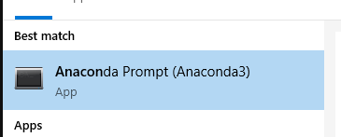

Command

**conda config --add channels conda-forge**

**conda install pymeasure**

I experienced error at the second command, just run the command again, it did not fix the problem.

So I use spyder

**Pip install pymeasure**

Now, check if pymeasure has been installed? On spyder, run

**import** **pymeasure**

pymeasure.__version__

Out[4]: '0.7.0' =>> succeed

# Step 3: install PyVisa

(ref. <https://pypi.org/project/PyVISA/>)

A Python package for support of the “Virtual Instrument Software Architecture” (VISA), in order to control measurement devices and test equipment via GPIB, RS232, Ethernet or USB.

**Pip install pyvisa**

Check if installation succeeded

**import pyvisa**

**pyvisa.__version__**

Out[8]: '1.10.0'

# Step 4: install keysight [IO library suite](https://www.keysight.com/main/software.jspx?ckey=2175637&lc=eng&cc=GB&nid=-33330.977662&id=2175637&pageMode=CV) to connect with the LCR through USB/Lan, etc

[how to connect LCR to LAN/USB](https://www.youtube.com/watch?v=sZz8bNHX5u4) (this link died)

# Step 5: Run Keysight connection expert and Set up IP Connection

run keysight connection expert

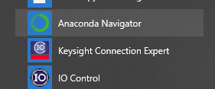

Get IP from the device

Run Keysight Connection Expert and configure as below

Note: Get the address from the LCR. Press System -> System config.

In my case, MANUAL IP ADDR = 130.216.166.66 / MANUAL SUBNET MASK 255.255.255.0

Set your computer to same subnet mask, leave gateway blank as you don’t need it.

Can press Test VISA or open instrument web interface to see if the connection is valid

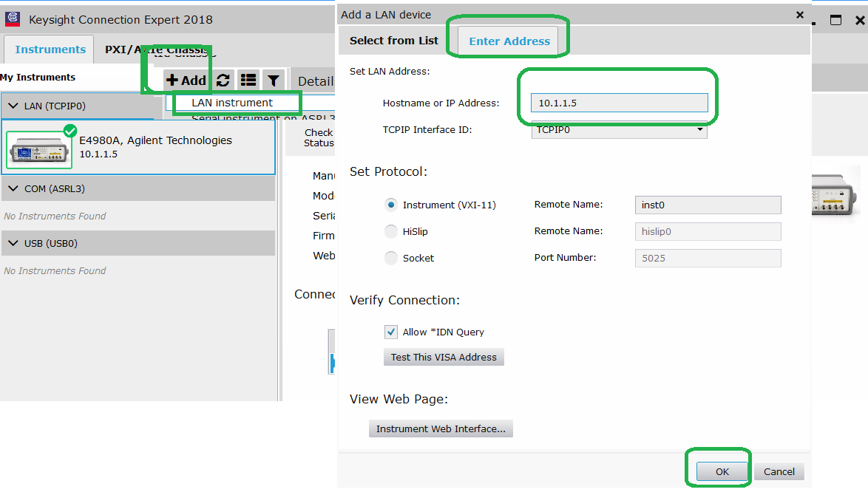

Now you see the device listed

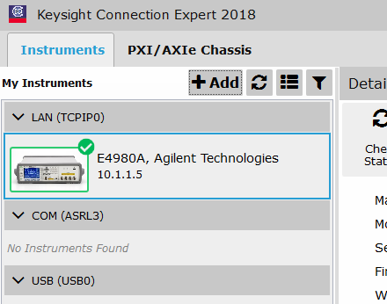

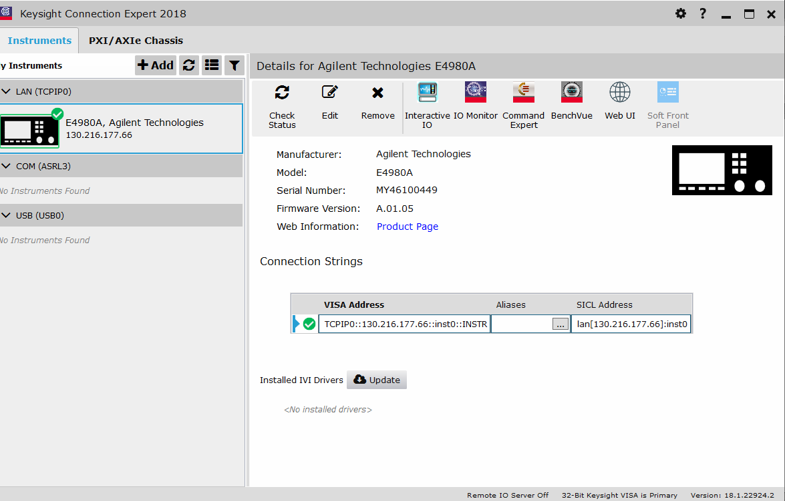

# Step 6: Run python code to test connection

First, test connection, remember to change the address of the device accordingly.

Make sure address and VISA library path is correct

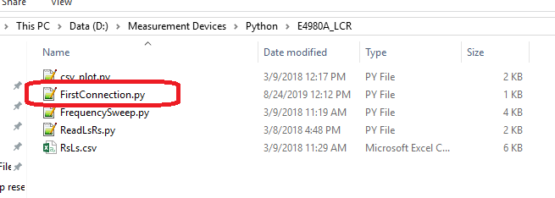

# Step 7: run Frequency Sweep.py

Again, make sure IP address and path of VISA lib is accurate. Output is LsRs.csv in the same folder with *.py source code

For this ver.1 code, make sure you set meas time to LONG, and turn correction Manually. Also, don’t forget to do calibration for the whole range. Google if you doubt.